**EVENT MANAGEMENT SYSTEM**

**Front End Development:**

Developed an Application named Event Management System, which is used, to allow the users for

* REGISTERING TO AN EVENT.
* BOOKING TICKECTS TO AN EVENT,
* SERVICES PAGE TO VIEW ALL THE EVENTS WE ORGANISE.
* PORTFOLIO TO VIEW THE IMAGES OF ALL THE EVENTS WE ORGANISED.
* CAREERS PAGE TO WORK WITH US.
* ABOUT US PAGE TO KNOW MORE ABOUT US.
* ADMIN PAGE FOR CONTROLLING THE REQUESTS.

**Requirement Specification:**

Once the application is loaded the first screen appeared as shown below:

**Event Management System: Home Page**

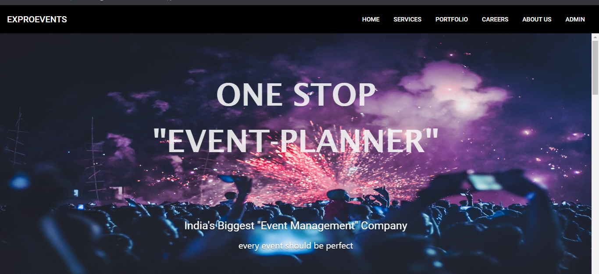

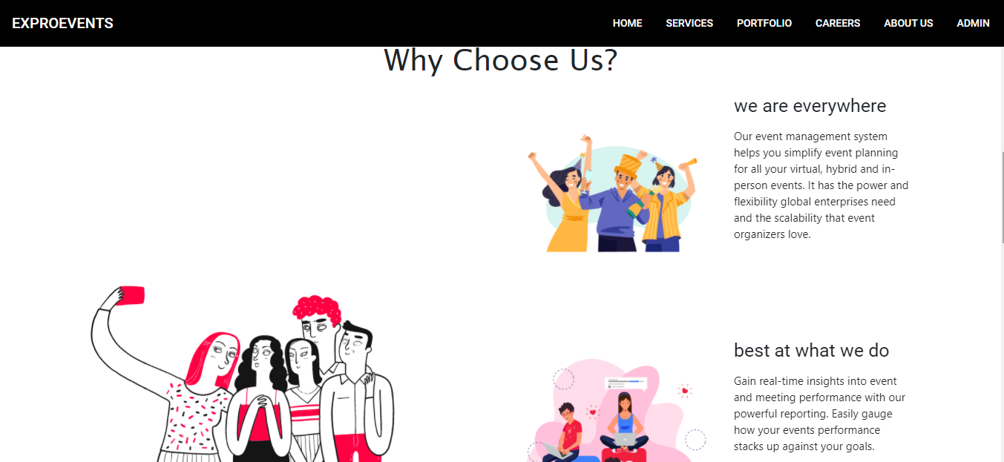

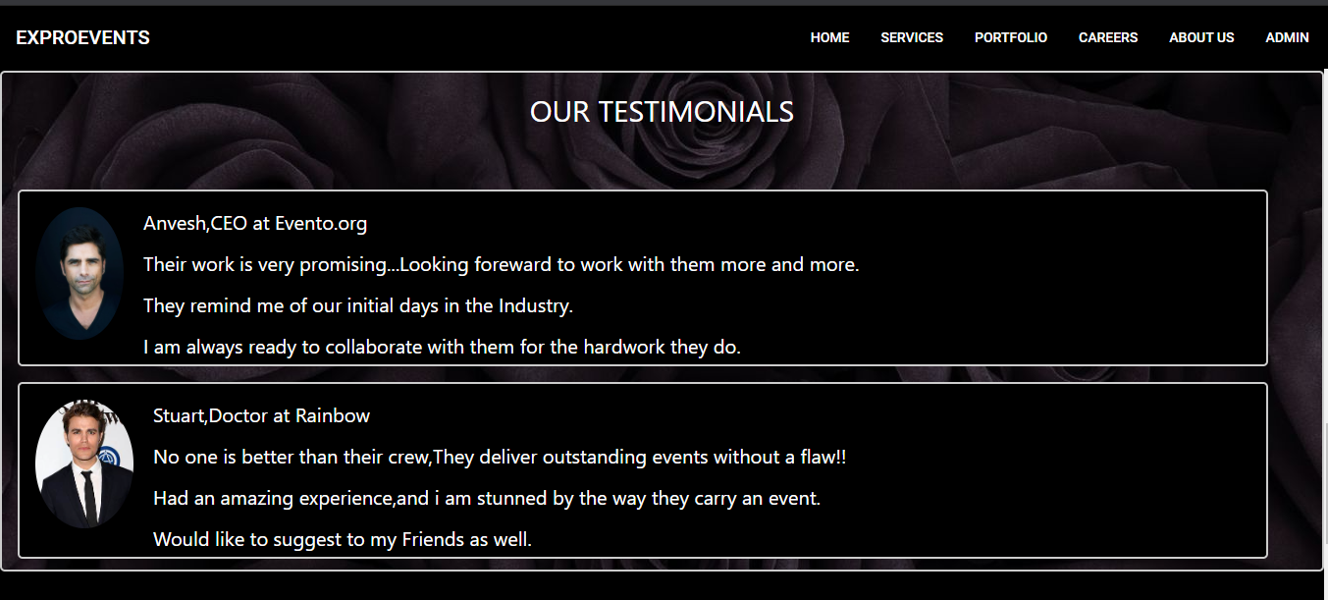

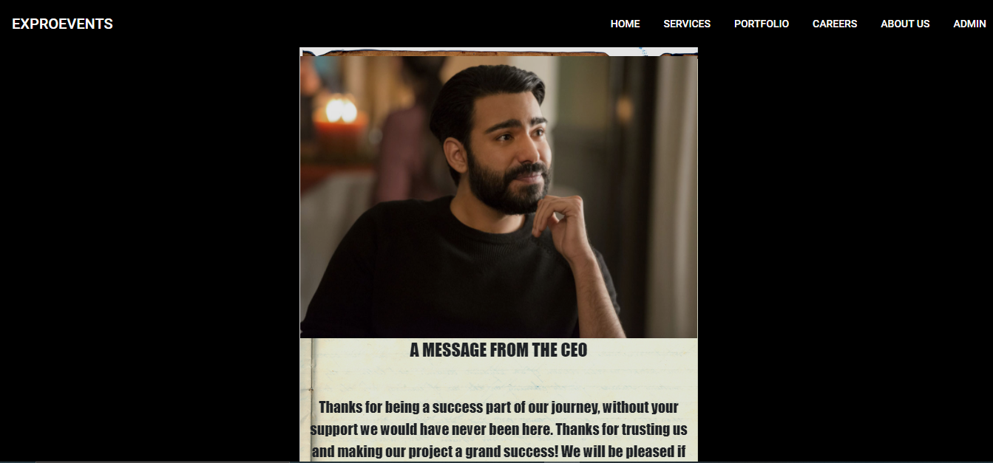

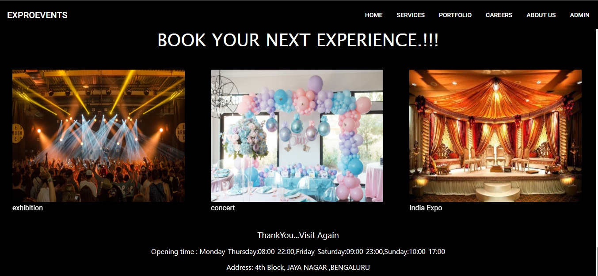

* When you placing the cursor on any of the images above we get a popup as shown below

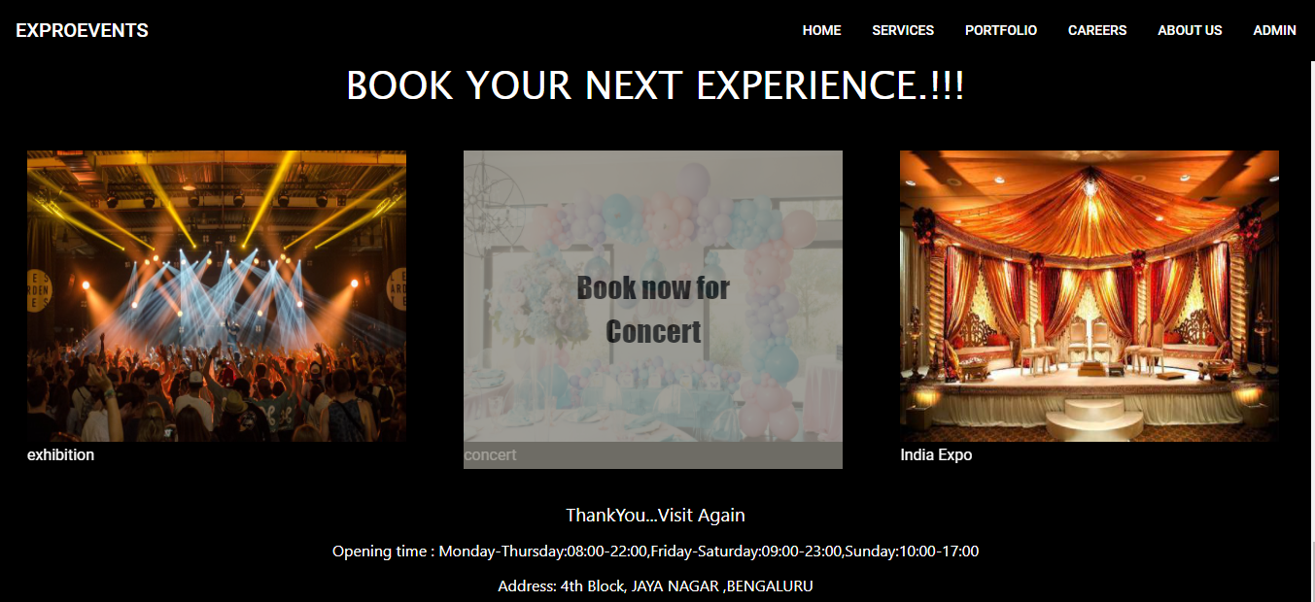

* When we click on one of these it will redirect us to the booking page.

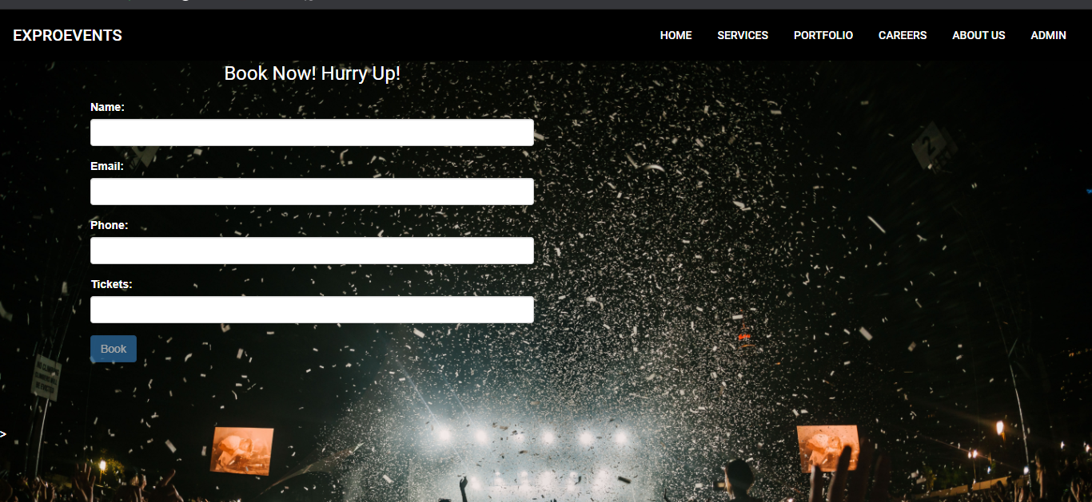

* When we fill the form and when we click on “Book” button it will redirect to homepage by saving details to database and details will be visible in the admin page.

**From the Home page we can be able to see the following Activities performed:**

* There is a navigationbar which provides links for other pages like Service,Portfolio, About-us, Careers,Admin Login.

## **SERVICE PAGE**

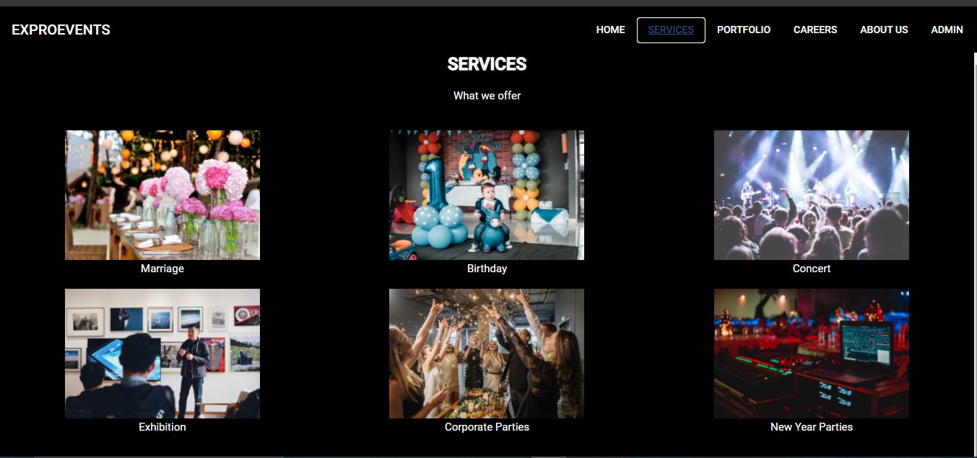

* By Clicking on SERVICESwe can see all images of the services we provide and if we click on a particular service it will redirect us to CONTACT US form.

## **CONTACT US PAGE**

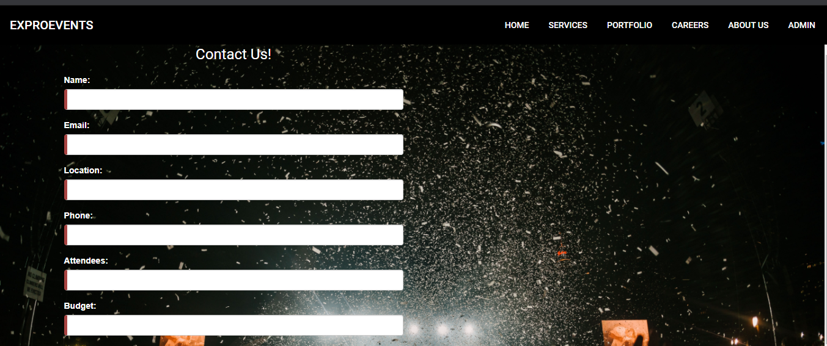

Contd…

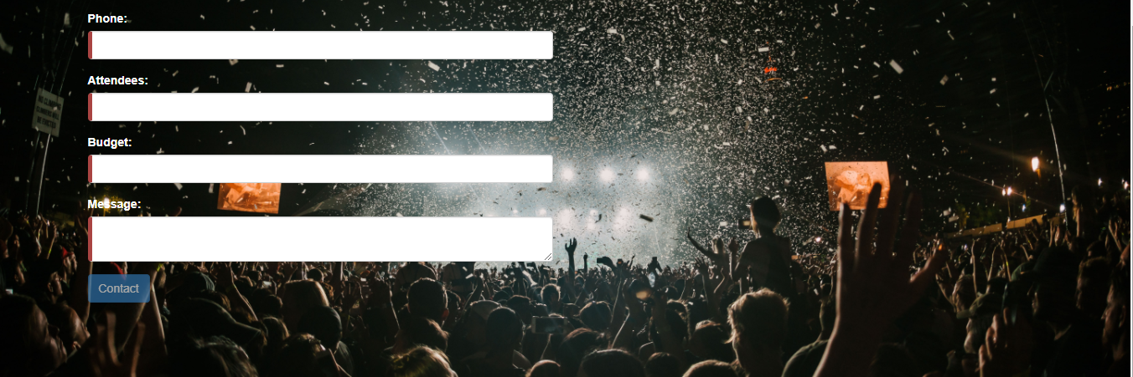

* The fields which we have in the CONTACT US form are
* NAME: Name field which takes only alphabets.
* EMAIL: Email field which should be in email format.
* LOCATION: This is used for the user to pick their respective location, where the event is to be hosted.
* PHONE: In the Phone field we have to enter the 10 digit mobile number.
* ATTENDEES: Attendees field to check number of attendees, attending the event.
* BUDGET: Budget field for finalizing budget to be spent on the event
* MESSAGE: Message from the user to the admin(It should not be less than 10 characters).
* After filling all these fields in the form the SUBMIT button gets enabled and when we submit the form and our details get updated in the ADMIN page and we get a pop-up saying “SUBMITTED SUCCESSFULLY”.

ADMIN SCREENSHOT

## **PORTFOLIO PAGE**

* In the PORTFOLIO page we have the images of various events like
* WEDDING EVENTS
* BIRTHDAY PARTIES
* NEW YEAR EVENTS
* CONCERTS
* CORPORATE EVENTS
* CONFERENCES

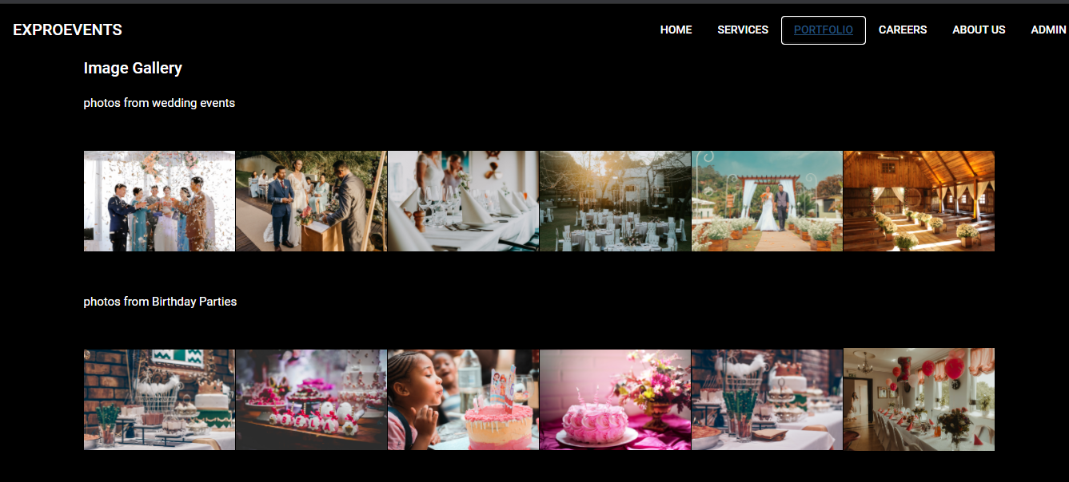

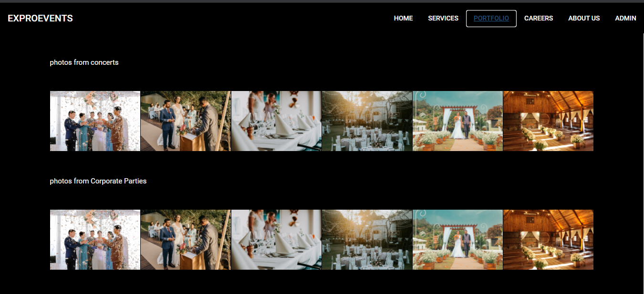

## **CAREERS PAGE**

* The CAREERS page include the job oppurtunities which are open in our company.
* If the user finds a job related to his qualification he can apply and join us.
* We have a REGISTRATION form for the users to apply for the job. The REGISTRATION form contains following fields
* FIRSTNAME
* MIDDLENAME
* LASTNAME
* COURSE:-The user can pick the course which relates to his studies.
* GENDER
* PHONE NUMBER
* CURRENT ADDRESS
* EMAIL
* SUBMIT
* When the USER submits the form, we consider his application if he is eligible for the job.

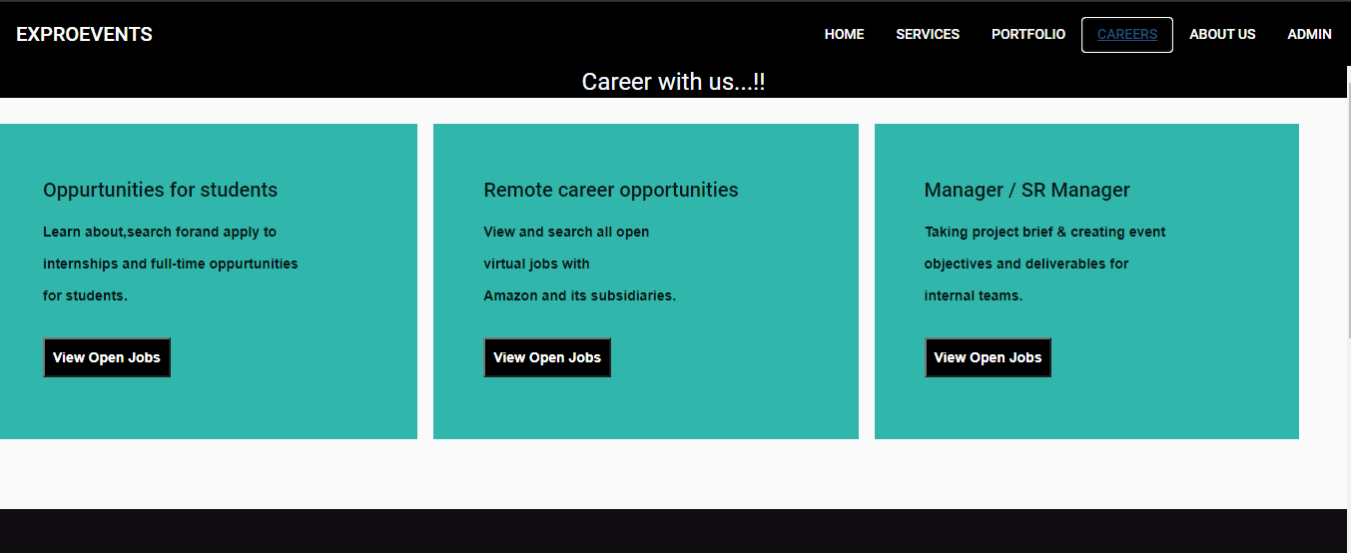

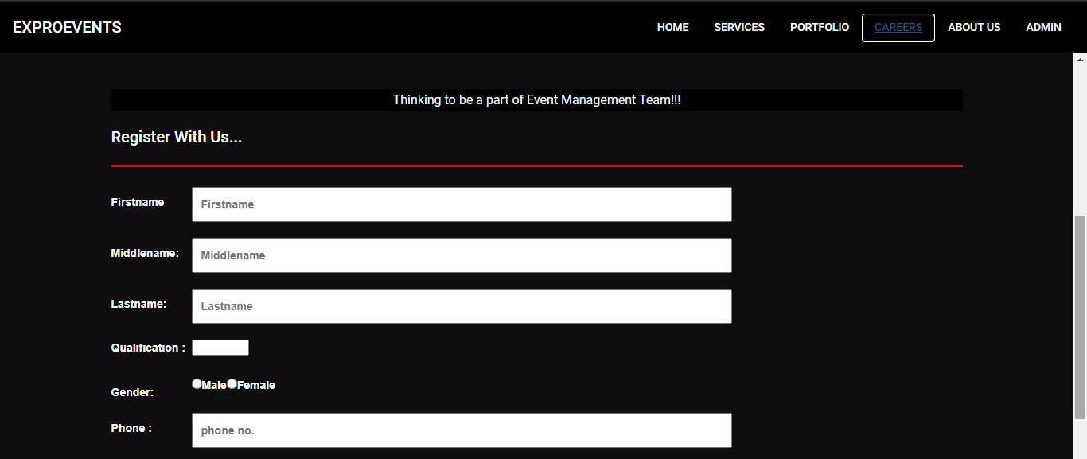

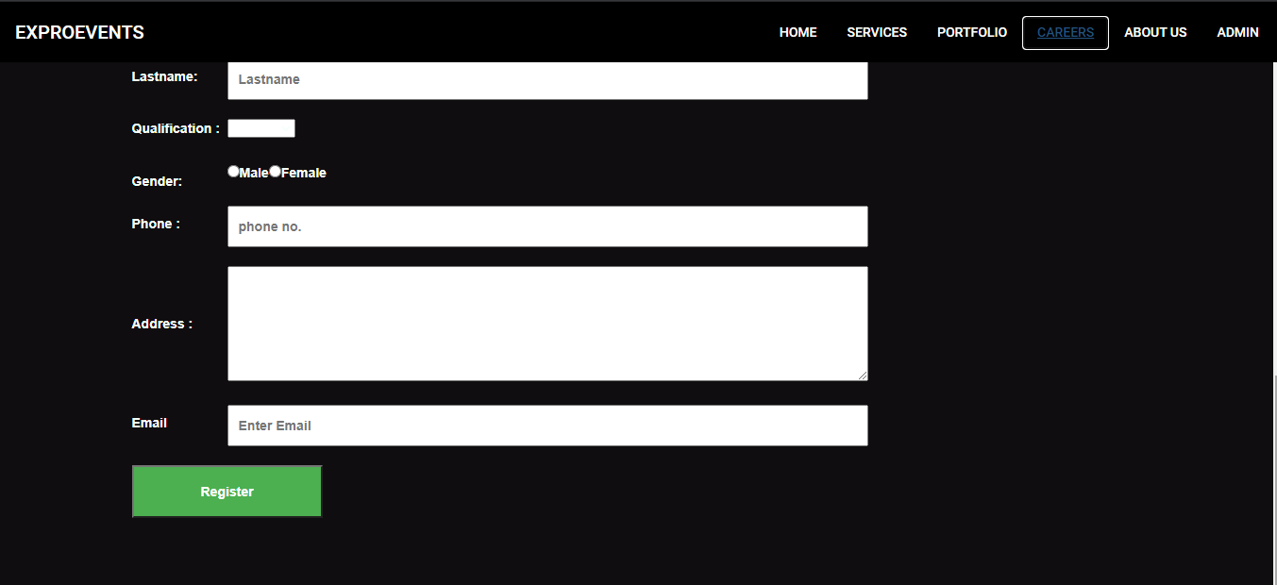

## **ABOUT US PAGE**

* ABOUT US page contains the complete details of each and every team member like
* NAME
* EMAIL
* CONTACT NUMBER
* The user can contact us in case of any queries.

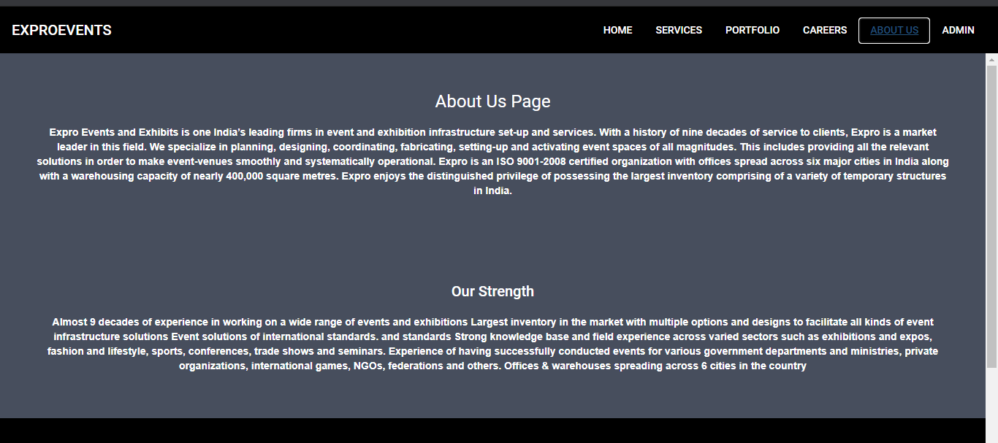

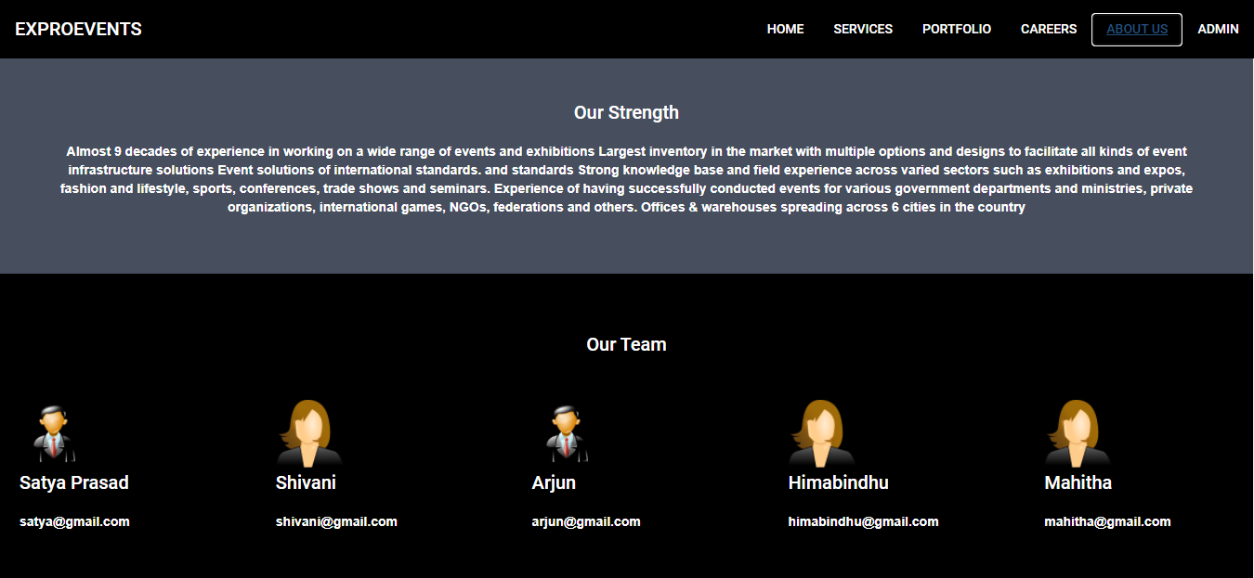

**ADMIN PAGE**

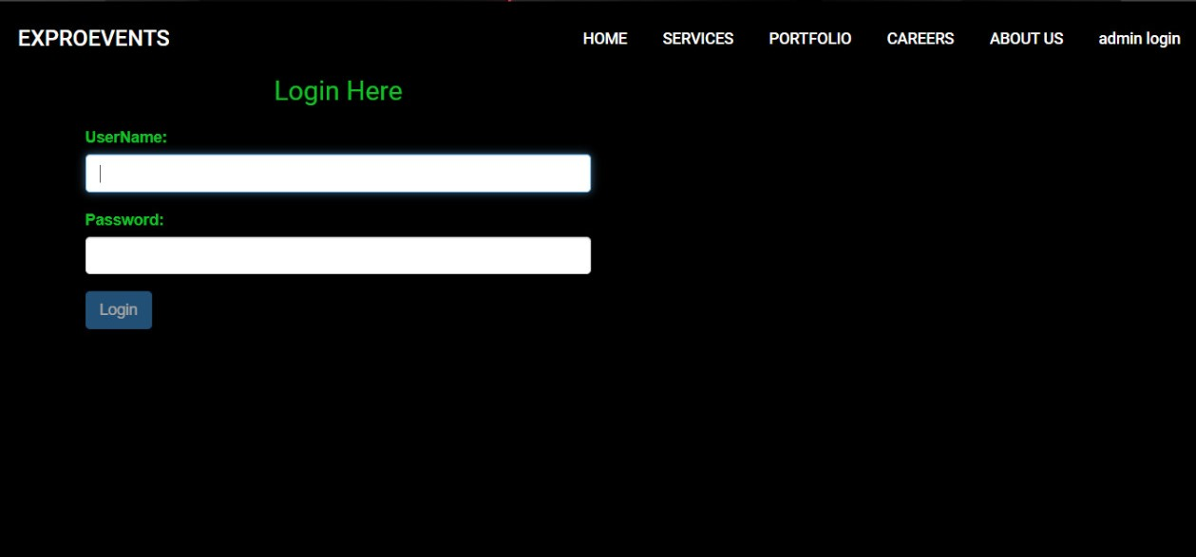

**Login page of ADMIN:**

If the ADMIN login by entering the appropriate credentials like USERNAME and PASSWORD in the login details the Login page redirect to the “ADMIN PORTAL” page. There we can see all the details of the

* BOOKED EVENTS
* CLIENT TICKETS
* CLIENT MESSAGES
* POTENTIAL LEADS
* DISPLAYING POTENTIAL LEADS
* AVAILABILITY OF VENUES

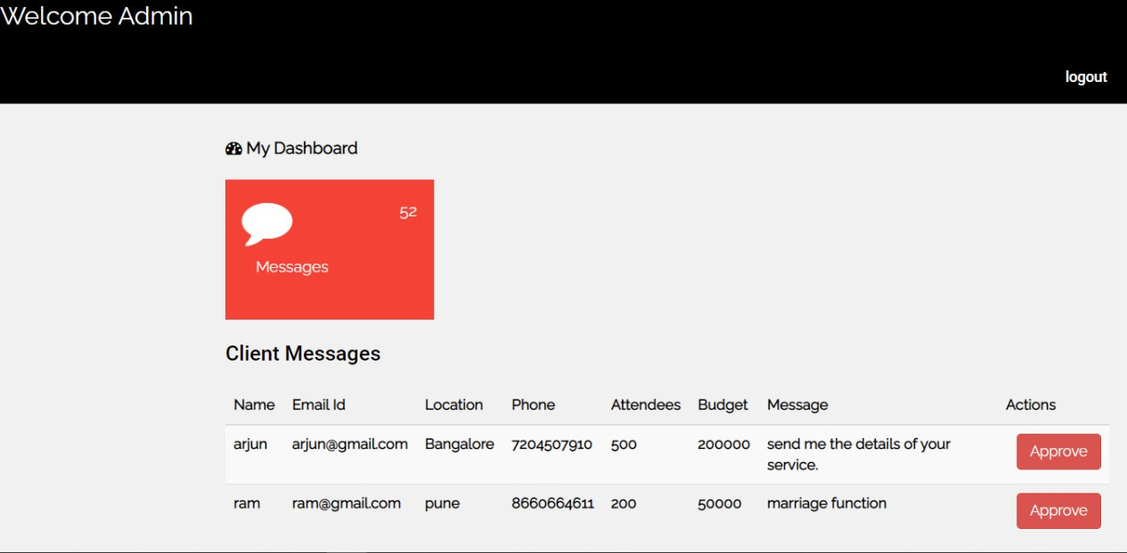

* The admin can have control on this client messages and client tickets, he can approve it and confirm.

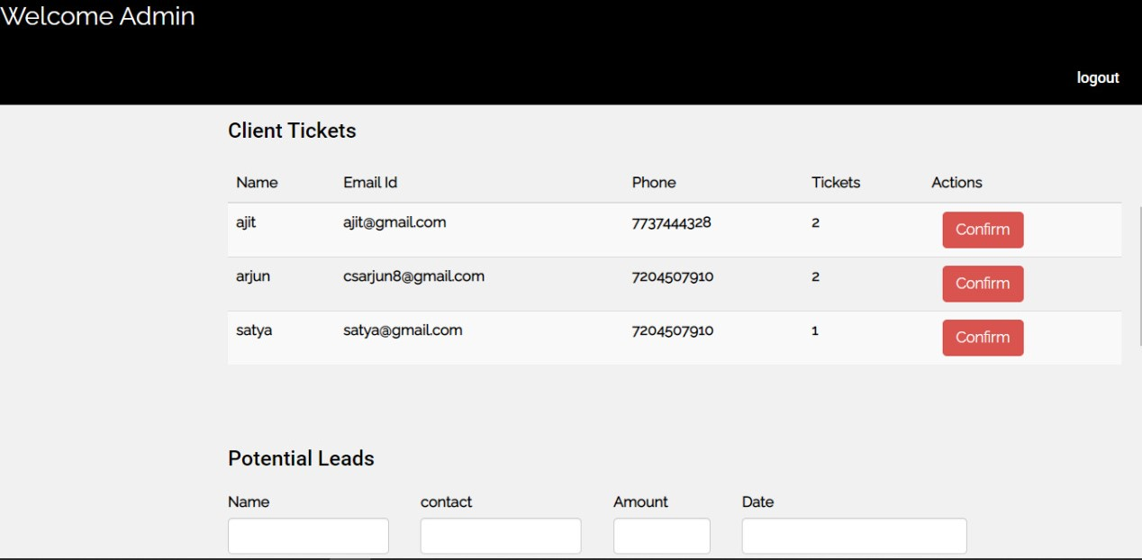

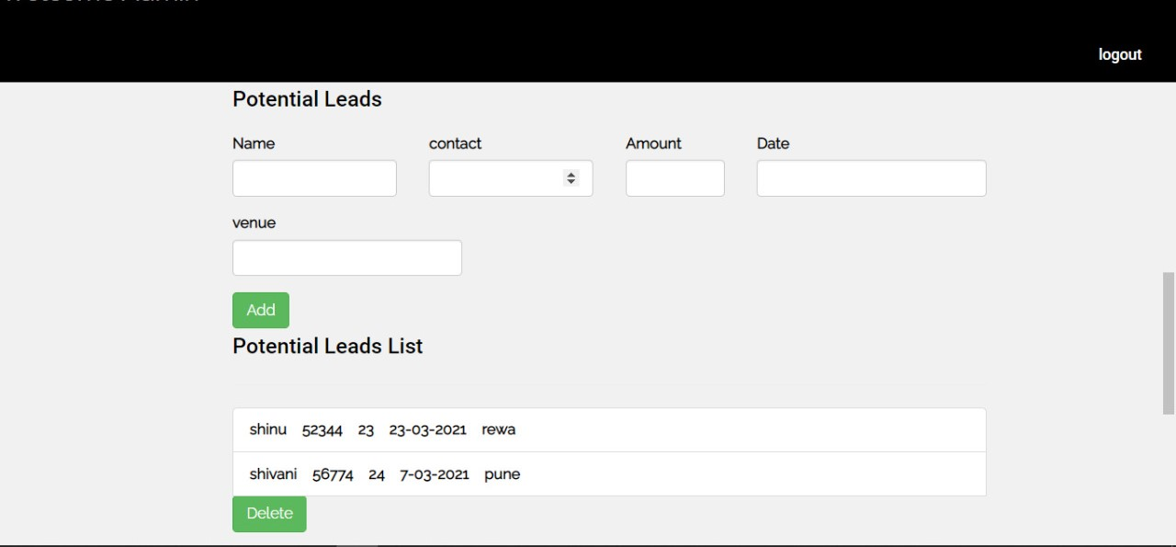

Whenever admin adds in the potential leads it will get reflected in the potential leads list.s